EXPERIMENT – 7
NAME: ANBUSELVAN V ROLL NO:240701038

AIM
Design and compare 3 login screen UI layouts with different color themes and evaluate user experience.
SCREEN DESIGN (Based on Your Images)
Common UI Structure (All 3 Layouts) • Title:

WELCOME
• Input Fields:
o Email / Username o
Password (with visibility icon)

• Checkbox: Remember me
- Primary Button: Login
- Links:
o Forgot Password o
Sign Up
- Divider: OR
- Social Login Options: o Google o Facebook o Email
LAYOUT VARIANTS

Layout 1 – Blue Theme (Minimal UI)
- Background: Light grey / white
- Primary color: Blue gradient button
- Style: Simple, clean, basic
- UI Feel: Functional but less attractive

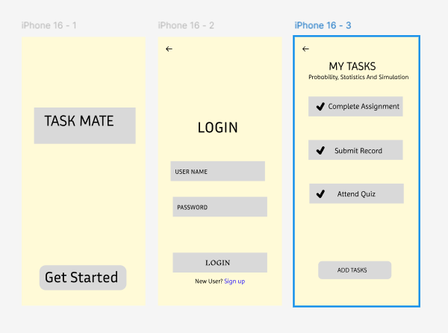
USER FEEDBACK (UI BASED)

Layout 1
- Simple and easy to use
- Needs better contrast
- Button looks flat
Link:
https://www.figma.com/design/wPPYFN3NYDzq9HMrTdoNwd/Untitled?t=O8lINxg4M5KqCNon-0
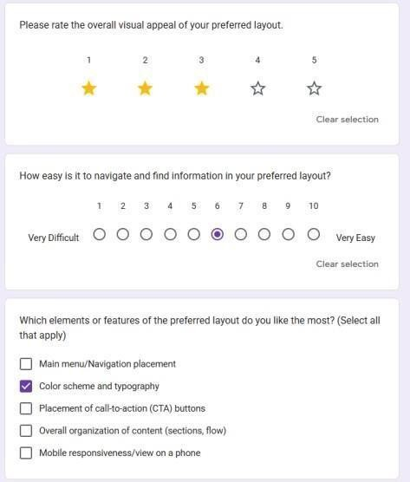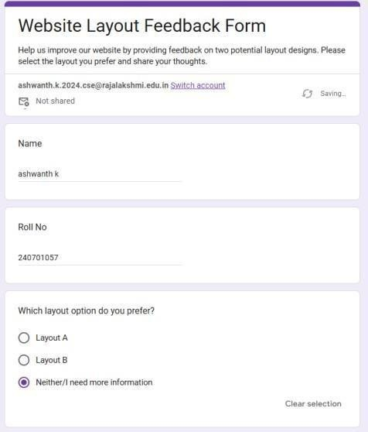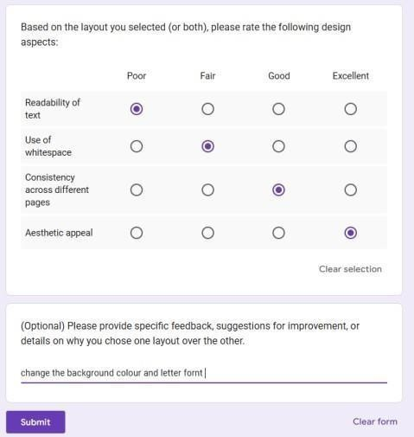

FINAL IMPROVEMENTS
- Add dark mode
- Add animations (button press, transitions)
- Improve accessibility (contrast C font size)
CONCLUSION:
The green-themed login UI (Layout 3) is the most effective design due to its clarity, usability, and professional appearance, making it the best choice for real- world applications.

